Project Development Phase
Model Performance Test

Date | 10 February 2025
Team ID | LTVIP2025TMIFD25057
Project Name | CRM Application for jewel Management
Maximum marks

Model Performance Testing:
Project team shall fill the following information in model performance testing template.
S.NO | Parameter | Values | Screenshot
1 | Metrics | Regression Model:  MAE - , MSE - , RMSE - , R2 score - | 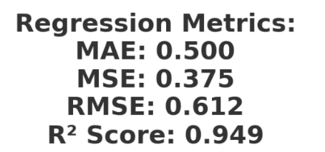
2 | Metrics | Classification Model:  Confusion Matrix - , Accuray Score- & Classification Report - | 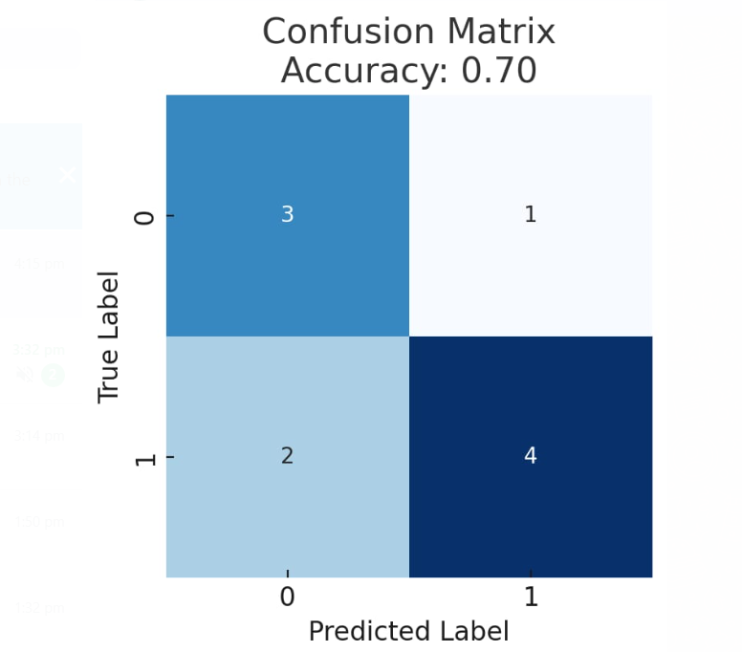
3 | Tune the Model | Hyperparameter Tuning -  Validation Method - | 